**Methodology for Projecting Future Year Vehicle Populations**

When activity data for inventories are not yet available or absent for a given year, it is standard practice to project or model the activity for future years until actual data becomes available. This method best describes how to project future year activity data for vehicle populations…

Vehicle Population Projection = Actual Vehicle Population X Projected Vehicle Miles Traveled

Actual Vehicle Miles Traveled

Note: Projected VMT is provided for in the VMT by County.xlsx file in the Forecasted Growth worksheet.

Example: Project 2019 Vehicle Populations

**Step 1. Set up the Equation**

2019 Vehicle Population Projection = (2017VPOPa/2017VMTa) * 2019VMTp

Where:

VPOPa = Actual vehicle population

VMTa = Actual vehicle miles traveled

VMTp = Projected vehicle miles traveled

**Step 2. Select Actual and Projected Activity Data**

2017 VPOPa = 1,242,840

2017 VMTa = 14,943,118,310

2019 VMTp = 15,096,169,070

**Step 3. Calculate**

2019 VPOPp = (1,242,840/14,943,118,310) * 15,096,169,070

2019 VPOPp = 1,255,569

**RESULTS**

Projected 2019 Vehicle Population Activity Data = 1,255,569

**ADDITIONAL NOTES**

This method was chosen as it generates results that are consistent with the national profiles for vehicle populations in operation in comparison to total vehicle miles traveled. The number of vehicles in operation are trending in the same direction as the total vehicle miles traveled each year since 1950 as depicted in this table below compiled by the Office of Energy Efficiency & Renewable Energy. (https://www.energy.gov/eere/office-energy-efficiency-renewable-energy)

May 27, 2019: Growth in Vehicle-miles of Travel and Number of Vehicles Outpaces Population Growth.

https://www.energy.gov/eere/vehicles/articles/fotw-1083-may-27-2019-growth-vehicle-miles-travel-and-number-vehicles

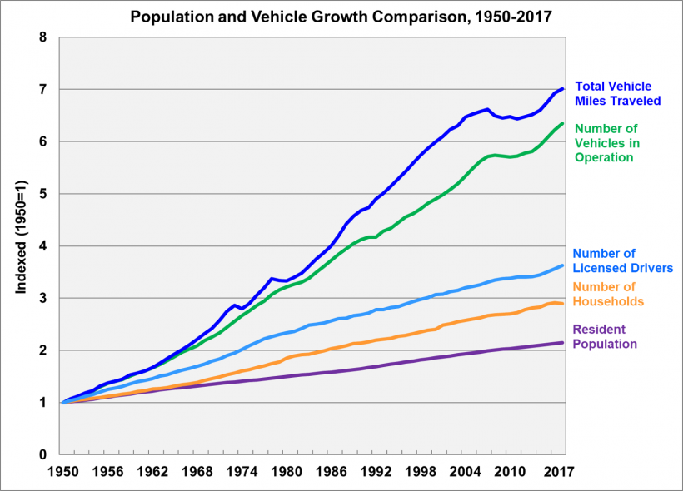

**Source:** Oak Ridge National Laboratory, [Transportation Energy Data Book: Edition 37.1](https://tedb.ornl.gov/), Oak Ridge, TN, 2019.

Once the statewide projections are made, a growth factor is determined and applied to the vehicle populations to distribute the growth rates to the individual vehicle classes. The following calculations are applied to determine the growth rates broken up into three parts.

The first part involves calculations for the Percent (Straight-Line) Growth Rate to determine the changes that occurred between the projected and actual vehicle populations. The second converts the Percent Rate over to a Growth Factor. Part three applies the growth factor to the individual vehicle classes to determine new populations by vehicle class at the county or town level.

Part 1. Calculate Percent (Straight-Line) Growth Rates where the percent of change from one period to another is calculated using the following formula…

Percent Rate = VPresent – VPast X 100

VPast

Example: Project the Percent (Straight-Line) Growth Rate for vehicle population between 2017 Actual activity data and the 2019 Projected activity data.

**Step 1. Set up the Equation**

2019 Vehicle Population Percent of Rate Changes

2019 Percent Growth Rate = [(2019VPresent – 2017VPast)/2017VPast)] x 100

Where:

VPresent = Present or future vehicle population value

VPast = Past vehicle population

**Step 2. Select the present and past values**

2017 VPast = 1,242,840

2019 VPresent = 1,255,569

**Step 3. Calculate**

2019 Percent Growth Rate = [(1,255,569 – 1,242,840)/1,242,840)]x100

**RESULTS**

2019 Percent Growth Rate = 1.0242224

Part 2. Convert the Percent Growth Rate over into a Growth Rate Factor by converting the Percent Growth Rate into a decimal format and then add 1 in the following manner…

Growth Factor = (Percent Growth Rate/100) + 1

Example: Calculate the Growth factor for the 2019 Percent Growth Rate

**Step 1. Set up the Equation**

2019 Growth Factor = (2019 Percent Growth Rate/100) +1

Where:

2019 Percent Growth Rate/100 🡨converts the 2019 Percent Growth Rate into a decimal format

**Step 2. Select the data**

2019 Percent Growth Rate = 1.0242224

**Step 3. Calculate**

Growth Factor = (1.0242224/100) + 1

**RESULTS**

Growth Factor = 1.0102422

Part 3. Apply the Growth Rate to the projected vehicle populations to estimate growth for the individual vehicle classes in the following manner…

Projected Vehicle Population = Actual Vehicle Population X Growth Factor

Example: Apply the Growth Factor determined for the changes between 2017 Actual vehicle populations to the 2019 Projected vehicle populations to the 2017 vehicle populations by vehicle class.

**Step 1. Set up the Equation**

2019 Vehicle Population by Vehicle Class = 2017 Vehicle Population by Vehicle Class x Growth Factor

Where:

|  |  |
| --- | --- |
| **Vehicle Classes** | **2017 Vehicle Population** |
| Motorcycle | 48,822 |
| Passenger Car | 430,049 |
| Passenger Truck | 630,519 |
| Light Commercial Truck | 69,932 |
| Intercity Bus | 307 |
| Transit Bus | 448 |
| School Bus | 3,558 |
| Refuse Truck | 1,342 |
| Single Unit Short-haul Truck | 42,779 |
| Single Unit Long-haul Truck | 2,730 |
| Motor Home | 4,232 |
| Combination Short-haul Truck | 4,542 |
| Combination Long-haul Truck | 3,580 |
| Total | 1,242,840 |

Growth Factor = the factor determined for the 2017 to 2019 vehicle population growth.

**Step 3. Calculate**

|  |  |  |  |
| --- | --- | --- | --- |
| **Vehicle Classes** | **2017 Vehicle Population** | **Growth Factor** | **2019 Vehicle Population** |
| Motorcycle | 48,822 | 1.0102422 | 49,322 |
| Passenger Car | 430,049 | 1.0102422 | 434,454 |
| Passenger Truck | 630,519 | 1.0102422 | 636,977 |
| Light Commercial Truck | 69,932 | 1.0102422 | 70,648 |
| Intercity Bus | 307 | 1.0102422 | 310 |
| Transit Bus | 448 | 1.0102422 | 453 |
| School Bus | 3,558 | 1.0102422 | 3,594 |
| Refuse Truck | 1,342 | 1.0102422 | 1,356 |
| Single Unit Short-haul Truck | 42,779 | 1.0102422 | 43,217 |
| Single Unit Long-haul Truck | 2,730 | 1.0102422 | 2,758 |
| Motor Home | 4,232 | 1.0102422 | 4,275 |
| Combination Short-haul Truck | 4,542 | 1.0102422 | 4,589 |
| Combination Long-haul Truck | 3,580 | 1.0102422 | 3,617 |
| Total | 1,242,840 | 1.0102422 | 1,255,569 |

**RESULTS**

|  |  |
| --- | --- |
| **Vehicle Classes** | **2019 Vehicle Population** |
| Motorcycle | 49,322 |
| Passenger Car | 434,454 |
| Passenger Truck | 636,977 |
| Light Commercial Truck | 70,648 |
| Intercity Bus | 310 |
| Transit Bus | 453 |
| School Bus | 3,594 |
| Refuse Truck | 1,356 |
| Single Unit Short-haul Truck | 43,217 |
| Single Unit Long-haul Truck | 2,758 |
| Motor Home | 4,275 |
| Combination Short-haul Truck | 4,589 |
| Combination Long-haul Truck | 3,617 |
| Total | 1,255,569 |

**APPENDIX A**

|  |  |  |
| --- | --- | --- |
| **sourceTypeID** | **sourceTypeName** | **Total Of 2017_BMV_ID** |
| 11 | Motorcycle | 48,822 |
| 21 | Passenger Car | 430,049 |
| 31 | Passenger Truck | 630,519 |
| 32 | Light Commercial Truck | 69,932 |
| 41 | Intercity Bus | 307 |
| 42 | Transit Bus | 448 |
| 43 | School Bus | 3,558 |
| 51 | Refuse Truck | 1,342 |
| 52 | Single Unit Short-haul Truck | 42,779 |
| 53 | Single Unit Long-haul Truck | 2,730 |
| 54 | Motor Home | 4,232 |
| 61 | Combination Short-haul Truck | 4,542 |
| 62 | Combination Long-haul Truck | 3,580 |
|  |  | 1,242,840 |

Source: https://www.maine.gov/dep/air/mobile/vehicle-data.html

File: Vehicle population.xlsx file, partial clip of the 2017_NEI_VPOPv1_Final worksheet data

**APPENDIX B**



Source: https://www.maine.gov/dep/air/mobile/vehicle-data.html

File VMT by County.xlsx, partial clip from Forcasted Growth worksheet.